Neha singh

RESTful Services

What is a Restful Service?

REST stands for Representational State Transfer. It is a architectural style that enable the communication between two systems using http protocol. Rest was first coined by Roy T. Fielding.

In REST architecture, Server provides access to resources and the rest client access and present the resource. Each resource is identified by the URI.

REST uses various data representations to represent a resource like Text, JSON, XML.

JSON format is most popular format used by Web api

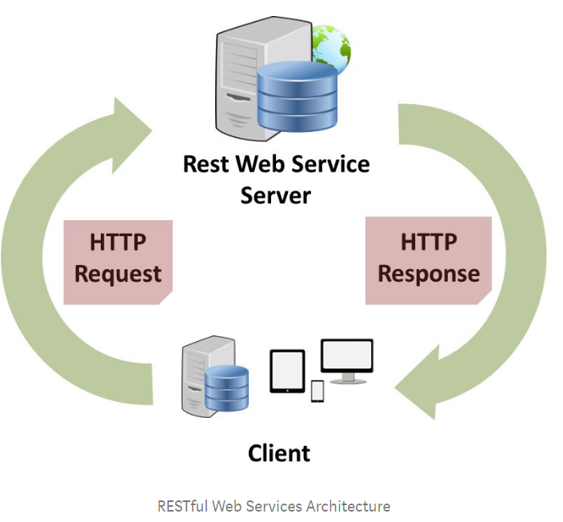

# HTTP Methods:-

Following http methods are most commonly used in the REST archetuture

* GET – It provides a read only access to a resource.
* POST – It is used to create a new resource
* PUT – It is used to update a existing resource
* DELETE – It is used to delete a existing resource.

# How REST client communicates to Server.

Client request server for a REST resource in the form of URI(e.g: Api/Customer/Create). Server finds the resource and return the response as requested by client.

For example For a Customer Api, we need

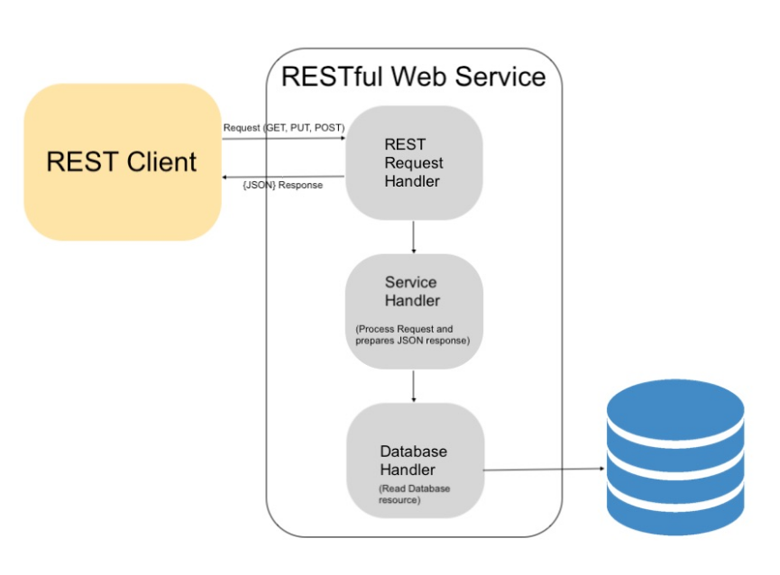

**Example:-**

|  |  |  |  |
| --- | --- | --- | --- |
| Customer Api Actions | Http Verbs | Url | Notes |
| CreateCustomer | POST | POST Api/Customer/Create | It will create the customer record in Database. Say 111 is customer Id created. |
| GetCustomer | GET | GET Api/Customer/111  Note: 111 is existing customer | It will fetch the existing customer from database based on given input. |
| UpdateCustomer | PUT | PUT Api/Customer/update | It will update customer 111 |
|  |  |  |  |